**OPIM 5604 B15 – Predictive Modeling Assignment Meghana Kasula (Net ID=mek15120)**

*“The work contained and presented here is my work and my work alone.”*

**a. Price Questions:**

i**) At what price are the laptops actually selling?**

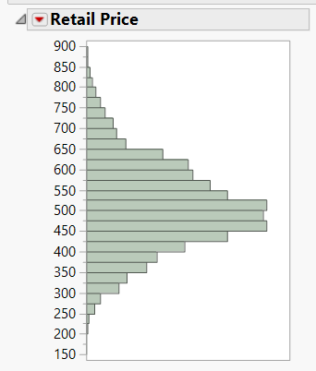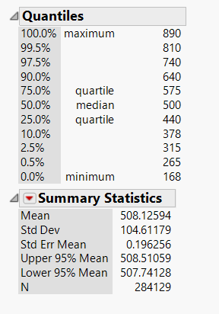Here, the Mean is 508.125, so we can infer that approximately, the laptops were sold at an average of this price.

**ii) Does price change with time?**

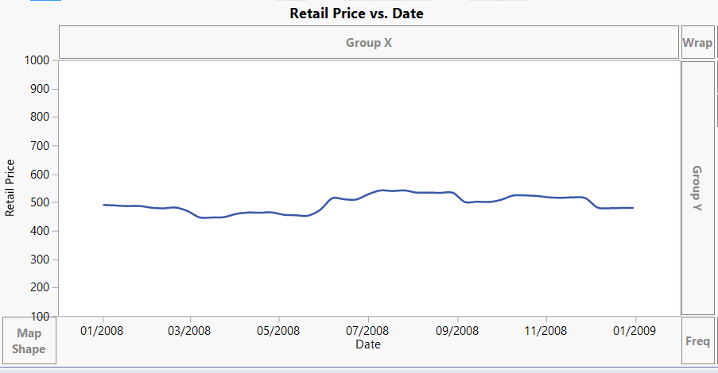

Yes, the price shows some variation as we go along with the time, interval of 2 months. We can always click on date and change the interval to weeks and days to see how it changed.

**iii. Are prices consistent over retail outlets?**

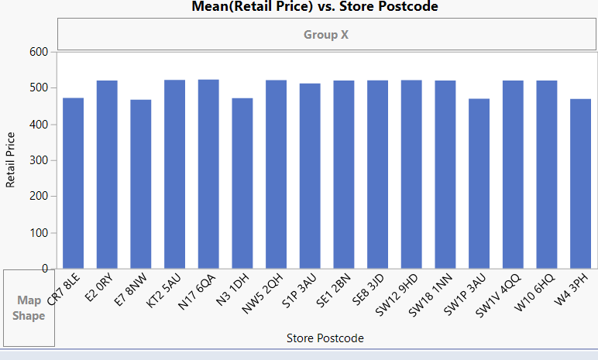Mean of Retail Price Vs store postcode shows us the above graph. Which is actually looking quite regular with minimal variations or without any drastic changes. We can therefore interpret that prices are nearly consistant.

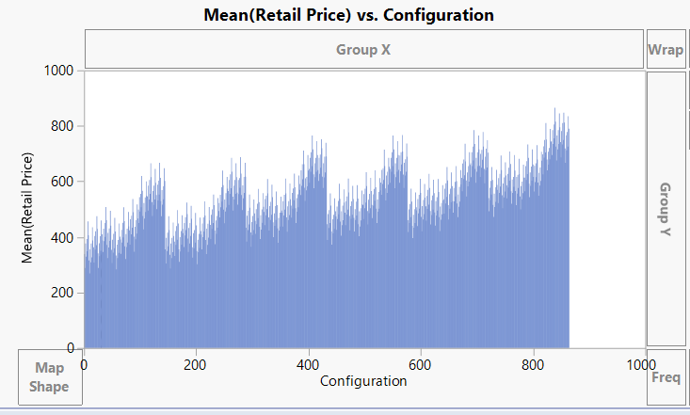**iv. How does price change with configuration?**

The above graph shows us the mean (Retail price) VS configuration value. There is a periodic increase and decrease.

Hence we can say that price is increasing but following with a decrease.

But no inconsistent fluctuation is noticed.

**b. Location Questions:**

**i. Where are the stores and customers located?**

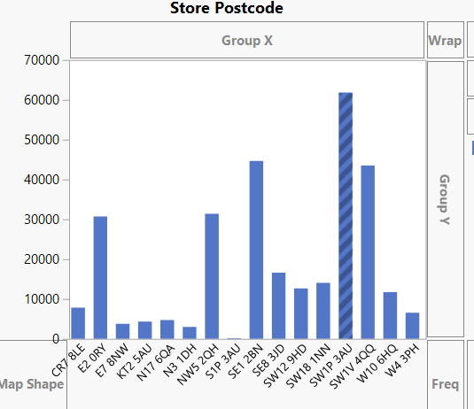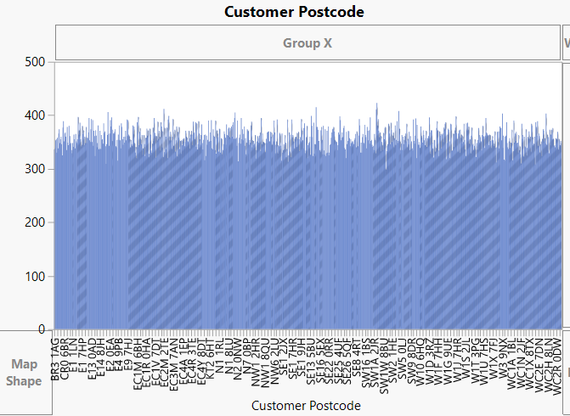

As we can see above, both the graphs from graph builder are plotted based on the customer and store postcodes. As we click on one store postcode, all the customer post code light up who visited that particular store. We can’t clearly say where exactly geographically present, but with this, we can definitely identify the target customers for a particular store.

**ii. Which stores are selling the most?**

Clearly, from the graph beside plotted against the mean of the retail prices, SW1P3AU.

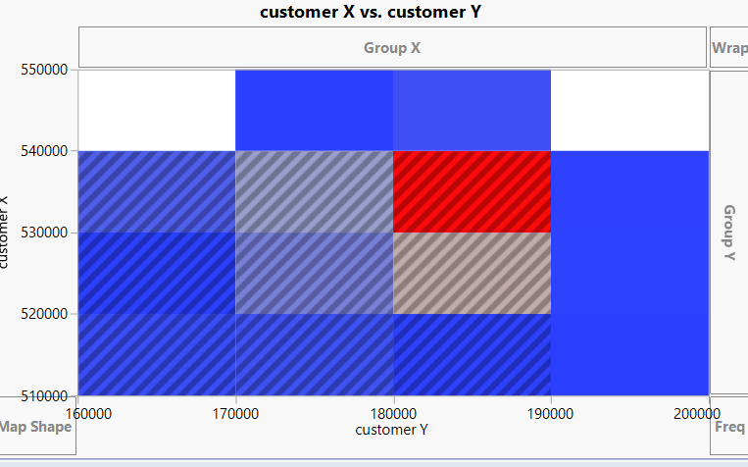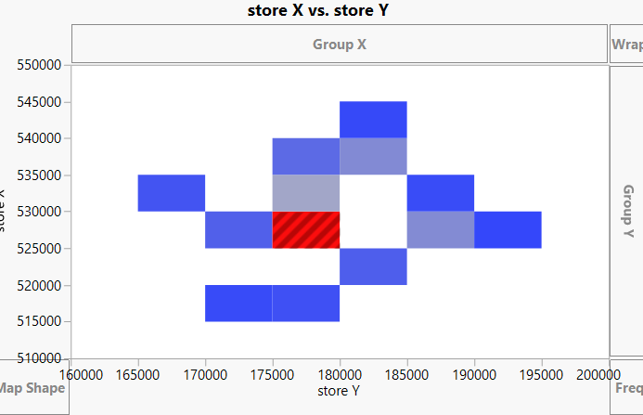**iii. How far would customers travel to buy a laptop?**

The two graphs above show the heat map of concentration of stores and heat map of concentration of customers. I have kept the minimum and the maximum, and the origin of the x and y coordinates same so that we can easily compare.

As I clicked on the most concentrated part of the stores, the customers related light up in the customer graph. This shows us the proximity of customers and stores and how they are related.

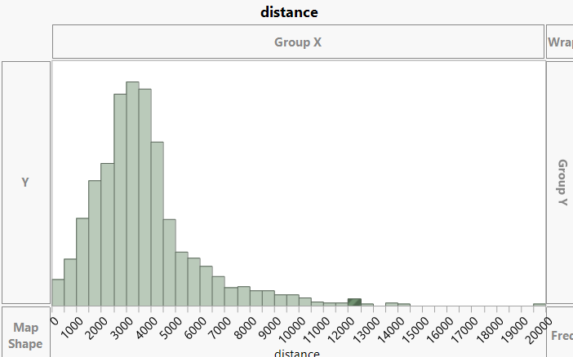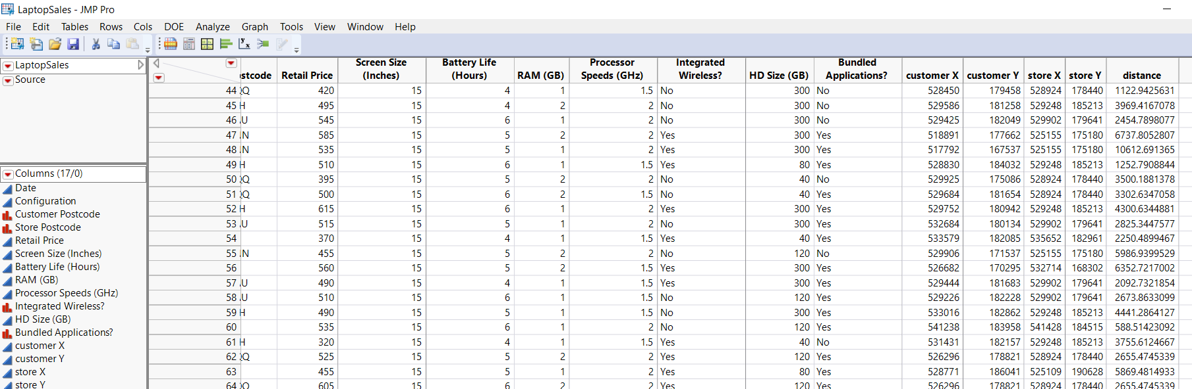**c. Try an alternative way of looking at how far customers traveled.**

The first table, shows the column creation to calculate the distance, which I did using the formula $\sqrt[2]{{\left(ϰ,-ϰ_{2}\right)}^{2}+ {\left(y,-y_{2}\right)}^{2}}$. Hence I distance travelled column.

Next, I analyzed the distance to get an idea about most covered distance.

**Revenue Questions:**

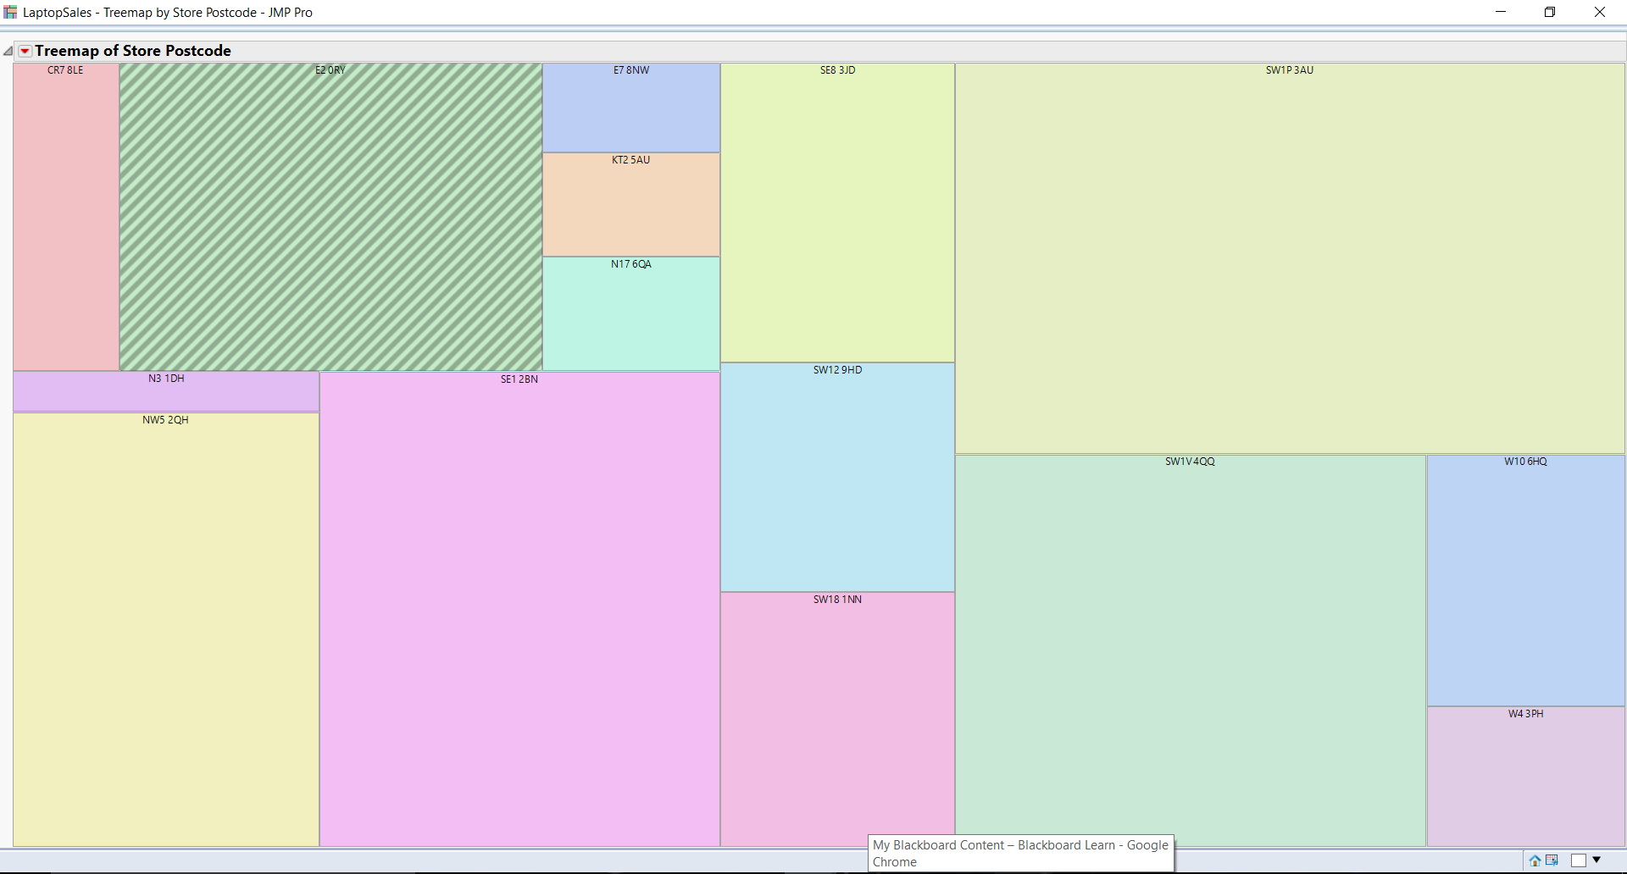**i. How do the sales volume in each store relate to Acell's revenues?**

This is a tree map to show the number of laptops sold and the store postcode and the total sales revenue percentage too.

If we hover over it, we would get all these details.

**ii. How does this depend on the configuration?**

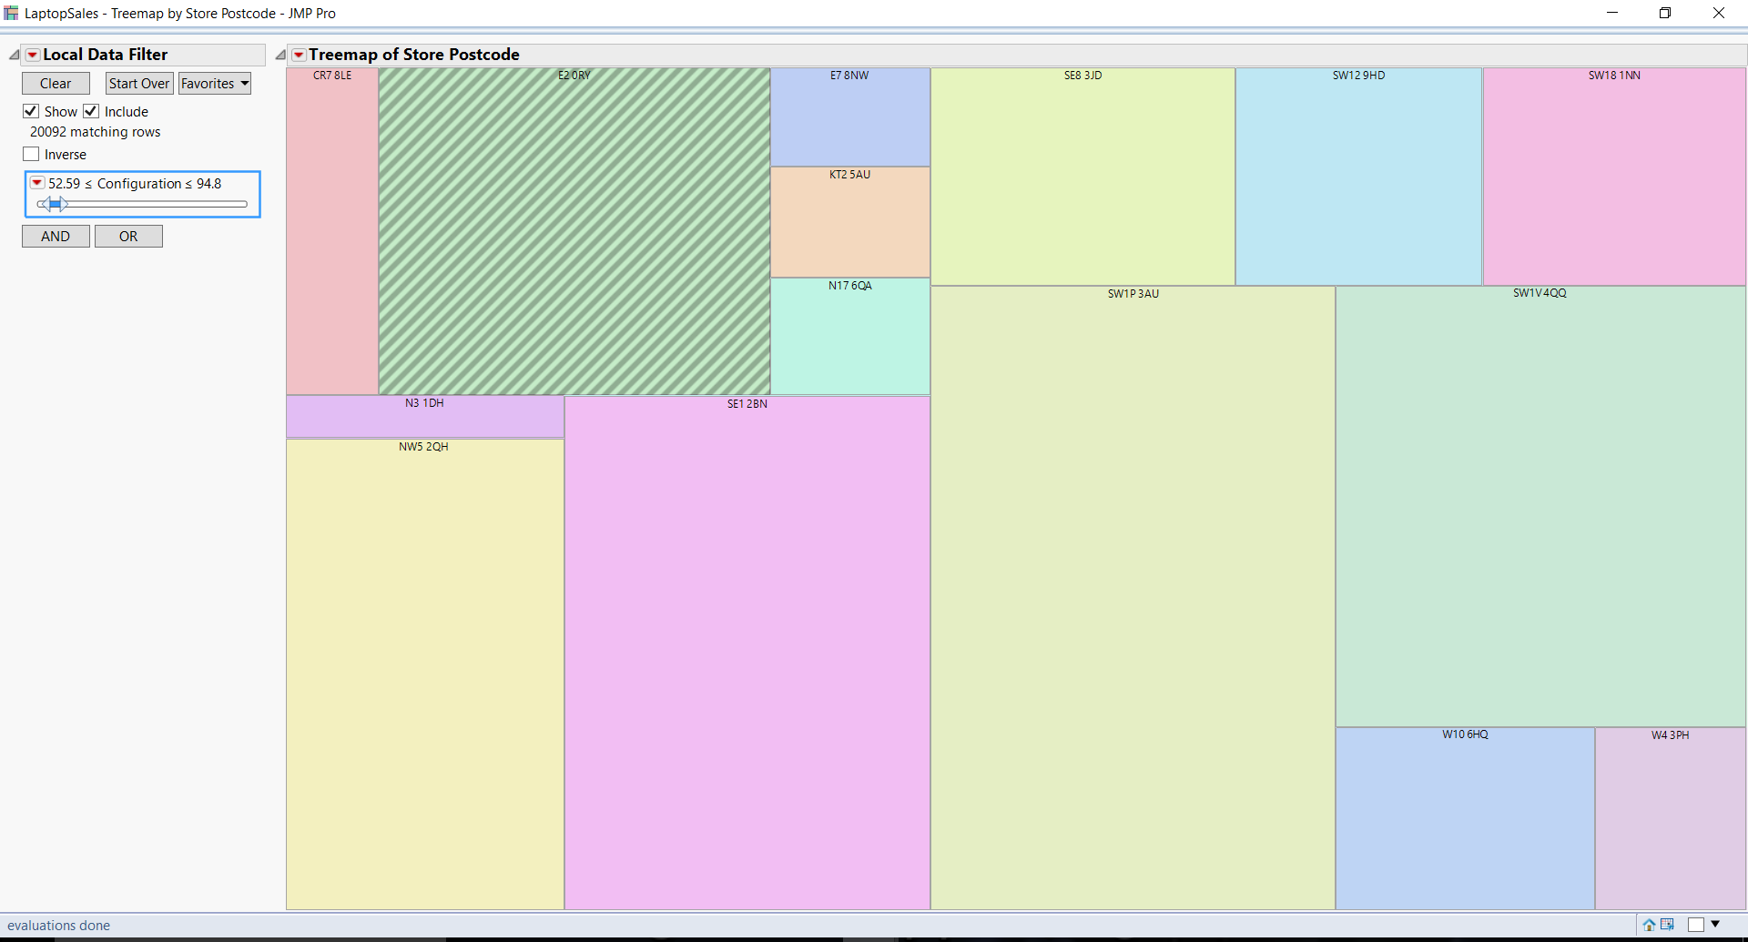

I added a filter of configuration to see the variation of all of these with configuration.

What I observed is that few stores do not have all configurations and at the same time, there is not much difference in the price but difference in the volume of the laptops sold.

**Configuration Questions:**

**i. What are the details of each configuration? How does this relate to price?**

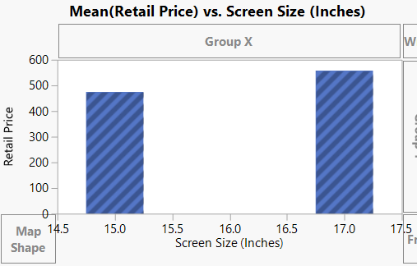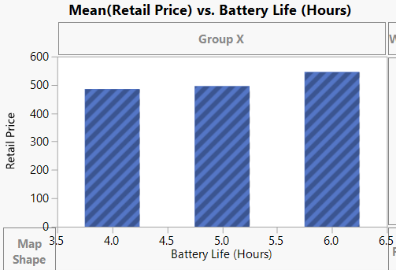

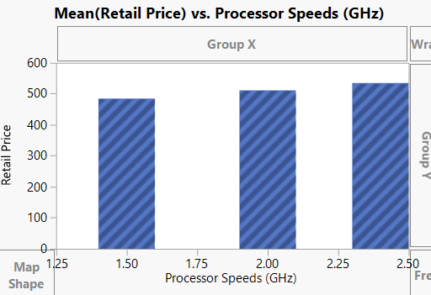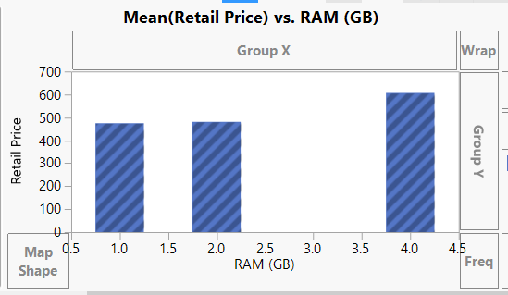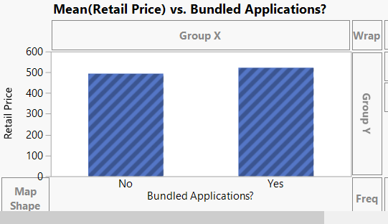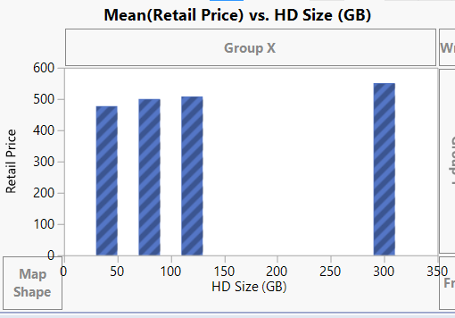

All the above graphs in this question show the variation of retail price mean with different specifications of laptop, or in simple terms different configurations.

**ii. Do all stores sell all configurations?**

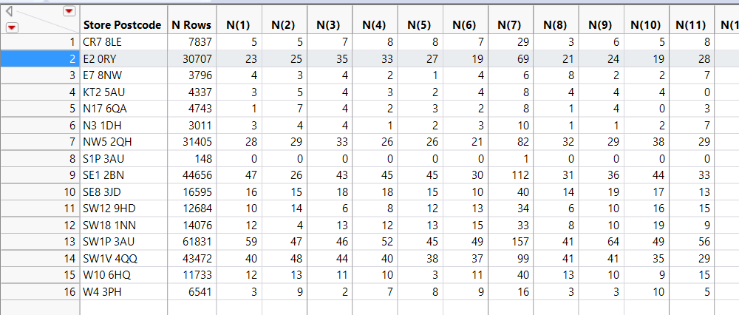

As we can clearly see, not all stores have the all the configuration. It can be seen in S1P3AU.